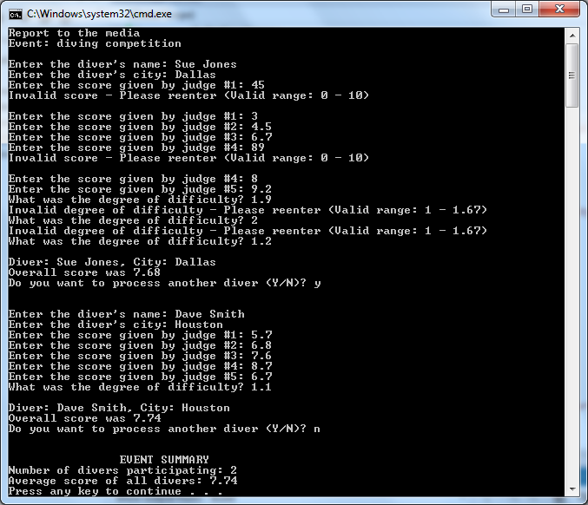

// ---------------------------------------------------------------

// Developer: Kevin Nguyen

// Date Written: 5/19/15

// Purpose: DIVER Scoring Program

// ---------------------------------------------------------------

#include<iostream>

#include<string>

#include<iomanip>

usingnamespacestd;

void main()

{

stringfirstName, lastName, city;

double score, total, final = 0;

double difficulty, highest, lowest, overall;

char diver;

intjudgeCounter, amtDivers = 0;

cout<<"Report to the media";

cout<<endl;

cout<<"Event: diving competition"<<endl<<endl;

cout<< fixed <<showpoint<<setprecision(2);

do

{

cout<<"Enter the diver's name: ";

cin>>firstName>>lastName;

cout<<"Enter the diver's city: ";

cin>> city;

// Variables

highest = -1;

lowest = 11;

total = 0;

judgeCounter = 1;

do

{

cout<<"Enter the score given by judge #"<<judgeCounter<<": ";

cin>> score;

while (score < 0 || score > 10)

{

cout<<"Invalid score - Please reenter (Valid range: 0 - 10)\n\n";

cout<<"Enter the score given by judge #"<<judgeCounter<<": ";

cin>> score;

}

if (score > highest)

highest = score;

if (score < lowest)

lowest = score;

total += score;

judgeCounter++;

} while (judgeCounter<= 5);

cout<<"What was the degree of difficulty? ";

cin>> difficulty;

while (difficulty < 1.0 || difficulty > 1.67){

cout<<"Invalid degree of difficulty - Please reenter (Valid range: 1 - 1.67)\n";

cout<<"What was the degree of difficulty? ";

cin>> difficulty;

}

overall = (total - lowest - highest) / 3 \* difficulty;

cout<<"\nDiver: "<<firstName<<" "<<lastName<<", City: "<< city <<endl;

cout<<"Overall score was "<< overall <<endl;

final = (final + overall)/amtDivers;

amtDivers = amtDivers + 1;

cout<<"Do you want to process another diver (Y/N)? ";

cin>> diver;

cout<<"\n\n";

diver = toupper(diver);

}

while (diver == 'Y');

cout<<" "<<"EVENT SUMMARY"<<endl<<"Number of divers participating: "<<amtDivers<<endl<<"Average score of all divers: "<< overall <<endl;

system("pause");

}